Database Systems for Future Trading INC.
Jorge Camacho-Machado, Dominique J Mben Tuang,
Nigina Rakhmatullaeva
IT 310: Database Technology
Dr. Michelle Liu
December 12, 2023

Abstract
The Organization Future Trading INC is a leading firm in the financial sector specializing in
future trading. The company needs a stable and reliable database management system where it will ultimately contribute to its continued and future success. Our team developed the proposal,
presentation, and finally brief entity relationship diagram, and sample SQL queries that will
allow users to retrieve useful information. The proposal covers the Business Profile that includes a brief description, the functions that that system performs, the end users. In the entity
relationship diagram we covered the meaning of each attribute, the role of the attribute, the
relationship between entities and their type, the assumptions, and the visual diagram that
includes crow’s foot notations covered during the semester. In addition, our team determined the
tables from the e-r diagram that marked the primary key, foreign key, and the arrows that show the relationship between tables. As we move forward with the project, we anticipate making updates and revisions in the long term. We understand the importance of being flexible and
adaptable in this evolving environment of trading. Our ultimate goal is to create a robust and
efficient database system that supports the organization’s futures trading operations and
contributes to its overall success.

Table of Contents:
Introduction
Literature Review
Methodology
Results
Discussion
Conclusion
Recommendations
References
Appendices
Introduction
We came up with this idea and this business because our team members are highly qualified and
experienced in trading and it is an environment. The organization has dedicated 200 employees
that occupy a variety of roles including traders, sales representatives, risk management analysts,
IT specialists, and executive management. Each role is essential to the success of the
organization.
Literature Review
Some of the theoretical frameworks that we implemented for our project are many to many, one to many types of cardinalities between two entities. For instance, the ER relationships have the
trade, customer, employee, contract, risk management. Trade has one to many relationships towards employees, and one to many relationships towards risk management. The customer has
many to many relationships with trade, and the customer has many to one relationship with
employee, employee has many to one relationship with risk management, and contract can has
many to one relationship with a customer. To defend the last relationship mention, there could be
none or many contracts for a mandatory customer because the contract table will hold previous
contracts as well as the customer’s current contract if they sign up for one. We ensured that all of
our cardinalities didn't break the rules of normalization.
Methodology
The database system will perform the following:
Trade Management
Risk Management
Inventory Control
Billing and Accounting
Reporting
Results
Our following entities will be in our database are:
Trade: This will store comprehensive information about each trade, including trade ID, contract
details, transaction date, and the trader involved.
Contract: This will hold exhaustive details about the futures contracts, such as contract ID,
underlying assets, contract terms, and expiration date.
Employee: This will contain detailed employee information like employee ID, name, role,
contact information, and associated trades.
Customer: This will store extensive customer information, including customer ID, name, contact details, assigned employee, and associated trades.
Risk Assessment: This will hold risk assessment data related to each trade, including risk ID,
trade ID, risk score, and mitigation strategies.
The final ERD diagram and relationships for this project:
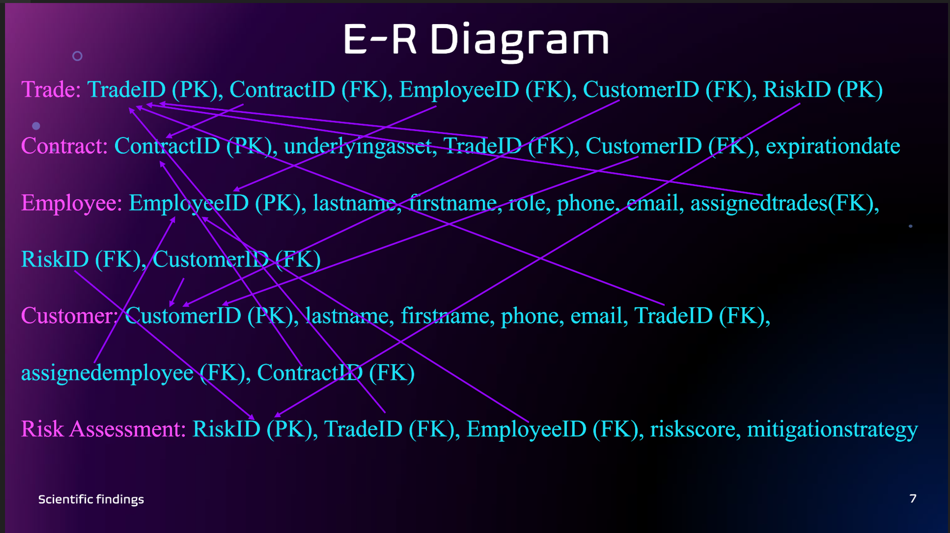
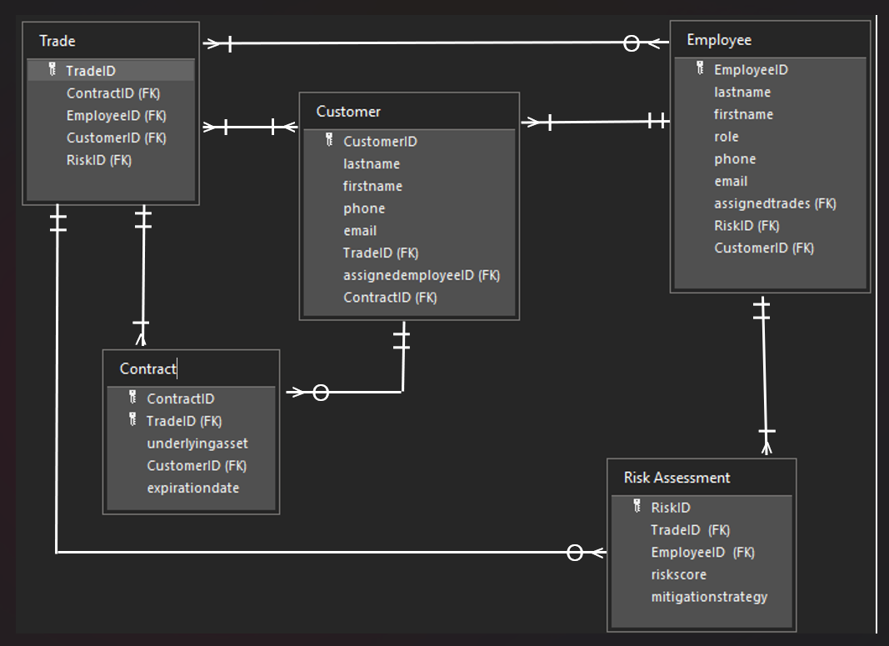
Discussion
Traders will have instant access to data and risk assessments, enabling them to make quick and
informed decisions. Sales representatives will have access to customer and contract information,
helping them serve their customers, risk management analysts will use the system for risk assessment and to devise mitigation strategies, accounting stuff that will handle invoicing and
transactions. IT specialists will maintain the system, ensuring data integrity and security.
Executive management will utilize the systems.
SQL Queries examples
i) The first query must include at least one built-in function;
Select *
From Customer;

ii) The second query must use WHERE to filter result;
Select *
From Risk Assessment
Where riskscore > 5;

iii) The third query must process multiple tables using INNER JOIN syntax;
Select TradeID.T, ContractID.CO, CustmerID.CU, expirationdata.CO
From Trade T inner join Contract CO
on T.TradeID = CO.TradeID
inner join Customer CU
on CO.ContractID = CU.ContractID
Order By expirationdate.CO DESC;

iv) The fourth query must process multiple tables using one-sided OUTER JOIN;
Select ContractID.CO, CustmerID.CU, firstname.CU, lastname.CU
From Customer CU left join Contract CO
on CU.ContractID = CO.ContractID
Where ContracID.CO = null;

Conclusion
In conclusion, some of the important implications of this projects are:
Data implementations
Normalization
Correct cardinalities
Coherent queries
Recommendations
For the further research and any actionable recommendations stemming from the project, the sql
queries must be carefully observed and implemented.
References
All sources were researched and reviewed from school material that is provided in canvas.
Appendices
Data, diagrams, and queries attached.
